**Database Management System (DBA) – 1 hour**

**FINAL TEST**

**Student ID: ____________________________________________________________ Student Name:__________________________________________________________ Class: _________________________________________________________________** *Instruction:*

**(*)** Write answer on your document and submit to submission box.

(*) Submission’s cut-off enabled: It means if you do not submit on time, box will be automatically closed without notifications.

**PART A. THEORY (4pts – 0.25 each)**

**1. Which one is not a characteristic of well-designed naming convention in key-value database?**

a. Use meaningful and unambiguous naming components, such as 'cust' for customer or 'inv' for inventory.

b. Use range-based components when you would like to retrieve ranges of values. Ranges include dates or integer counters.

c. Use a common delimiter when appending components to make a key. The ‘:’ is a commonly used delimiter, but any character that will not otherwise appear in the key will work.

d. Keep keys as long as possible.

**2. Which design pattern provides some of features of relational database transactions in RDBMS**

a. Time to live (TTL)

b. Aggregates.

c. Atomic aggregates.

d. Enumerable keys

**3. What are enumerable keys**

a. is a pattern that supports different attributes for different subtypes of an entity b. are keys that use counters or sequences to generate new keys

c. are sets of key-value pairs that allow for looking up keys or values by other attribute values of the same entity

**4. Which is NOT a characteristic of key-value database**

a. Simplicity

b. Speed

c. Scalability

d. Searchable value

e. All of the above characteristics are correct

**5. Which of the following rules are NOT belongs to JSON Object in Document database** a. Documents consist of key-value pairs separated by commas

b. Values can be numbers, strings, Booleans (true or false), arrays, objects, or the NULL value c. The values of objects are listed as key-value pairs within curly brackets, that is, { and } d. Keys can be any types (number, string, float, etc.)

6. **NoSQL databases is used mainly for handling large volumes of _____ data.** a. unstructured

b. structured

c. semi-structured

d. all of the mentioned

**7**. **Which of the following is correct statement of Google BigTable ?** a. Developers have dynamic control over columns

b. Data values are indexed by row identifier, column name, and a timestamp c. Reads and writes of a row are atomic

d. Rows are maintained in a sorted order

e. All of features above are correct

f. None is correct.

**8. In Column-family database, Primary key in a keyspace is a ____.** a. Column family

b. Row

c. Column

d. Data

**9. In Column-family database, Keyspace is similar to _____ in RDBMS** a. Table

b. Fields

c. Primary key

d. Schema

**10. Vertex represents relationships between nodes in graph database? True | False**

**11**. **A bipartite graph is is a graph with two distinct sets of vertices where each vertex in one set is only connected to vertices in the other set. (True | False)**

**12. Which of the following is not a Neo4J CQL command?**

a. CREATE

b. MATCH

c. DELETE

d. EXIT

**13. Joins in graph database are represented as**

a. constraint

b. Nodes

c. Relationships

d. Traversal

**14. The Elasticsearch default communication port is**

a. 9200/tcp

b. 3000/ip

c. 9200/udp

d. 3000/tcp

**15. In URI Search in ES, which of the following parameter denotes the number of hits to return in each request**

A. from

B. terminate_after

C. size

D. timeout

**16. A __________ breakdown fields values of a document into a stream, and inverted indexes are created and updates using these values, and these stream of values are stored in the document.**

A. analyzer

B. shard

C. filter

D. tokenizer

**PART B. SHORT ANSWER (3pts – 1.5pts each)**

**Write short answer for these questions**

**1. Given the following graphs nodes**

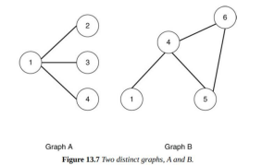

a. Draw graph as below to show unions of 2 graphs above (**0.75pts**)

b. Draw graph as below to show intersections of 2 graphs above (**0.75pts**)

**2. List enhancements of searching using Elasticsearch over Mysql search (using LIKE pattern) (0.75pts)**.

When talking about advantages, you should focus on features of Elasticsearch which Mysql cannot support.

**3. What is the difference between using PUT and POST in creating new document in ElasticSearch (0.75pts)**

**Part C. PROBLEM SOLVING (3pts)**

**1. Using Mongo, do the following tasks. (1.5pt – 0.75pts each)**

Given the following model.

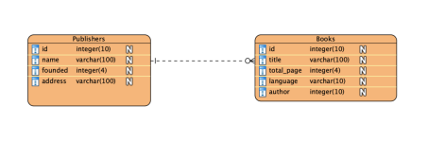**(*)** Note: a single book entity in the figure below can be written by many authors such as NguyenHuuCam and NguyenVanCong; therefore, using integer for author field of **Book** entity is not adequate due to incapability of using complex data structure in Visual paradigm. Note that Books entity can hold multiple authors in a single field.

(*) Founded attribute is the year when that publisher startups.

Insert sample data to transform this model into document database using BOTH normalized and denormalized format.

**2. Using MongoDB, write answer for the following queries (1.5pts)**

Given the following documents in table format and collection name is employee_info

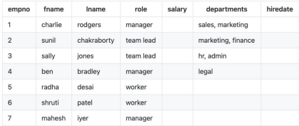

a. Write query to insert document with empno = 1 and empno = 7 into mongoDB (**1 pts**) b. Using aggregation, write query to count how many of each role exists in the collection above. (**0.5pts**). Result: manager – 3, worker - 2, team lead - 2